Project- 2

Ravinderbir Singh, Arshdeep Singh

Continental Institute of International Studies

IMDW-18011, IMDW-18003

Amandeep Singh Sohal

October 26, 2018

**INTRODUCTION**

In this project we are going to design a prototype of a blogger website in Justinmind Software. Name of the website is **WE BLOG** and this website will help the beginners to create a blogger website and the information given in the website is will be supportive to the users, easy to the users and informative to the users. Apart from this, it is based up on Business.

**DISCRIPTION**

The purpose of our website to make user feel free to make their own blogger website easily. Because it has a simple interface, anybody can make a blogger website here in just few steps. There are some future goals we also set for website like to make it more fluent, little cheap for paid users. All the Desirable Features we are using in this website are: –

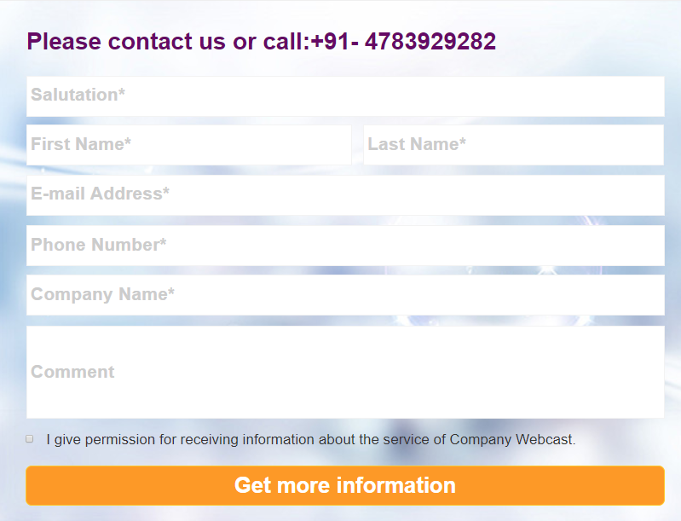

1. ***Webinars*** – Online classes might be utilized as an umbrella term for different sorts of online community administrations including web workshops ("online courses"), webcasts, and peer-level web gatherings. It might likewise be utilized in a thinner sense to allude just to the associate level web meeting setting, trying to disambiguate it from alternate sorts of collective sessions. Phrasing identified with these advances is estimated, and no for the most part settled upon source or model’s association exists to give a set up utilization reference.

* Things included in Webinars are: –
* Salutation – In this column a signal or articulation made as a welcome or affirmation of another's entry or flight.
* First Name – First name of the user should be there.
* Last Name – Last name of the user should be there.
* E-mail Address – E-mail of the user.
* Phone Number – Number of the user should be there.
* Company’s Name – Name of the company should be there of the user.
* Comment – In this section the user will give their views about the webinars.

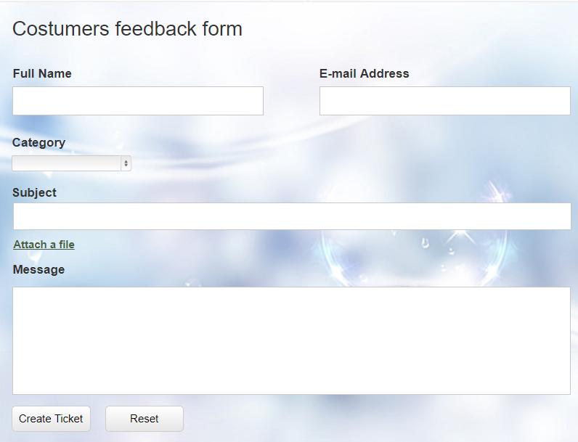

1. ***Support Forms*** – This is also known as Costumer Feedback Form (CFF). In this form Costumer give their own opinion about the experience of the website and what changes they want to see in the website.

* Things included in Support Forms are: –
* Full Name – User will enter here their full name.
* E-mail address – User will enter here their e-mail address.
* Category – The user will select the category here.
* Subject – Small title line describing the message of the user.
* Attach a file – Any file, image or document user want to attach.
* Message – the message user wants to give to other peoples and to the developer.

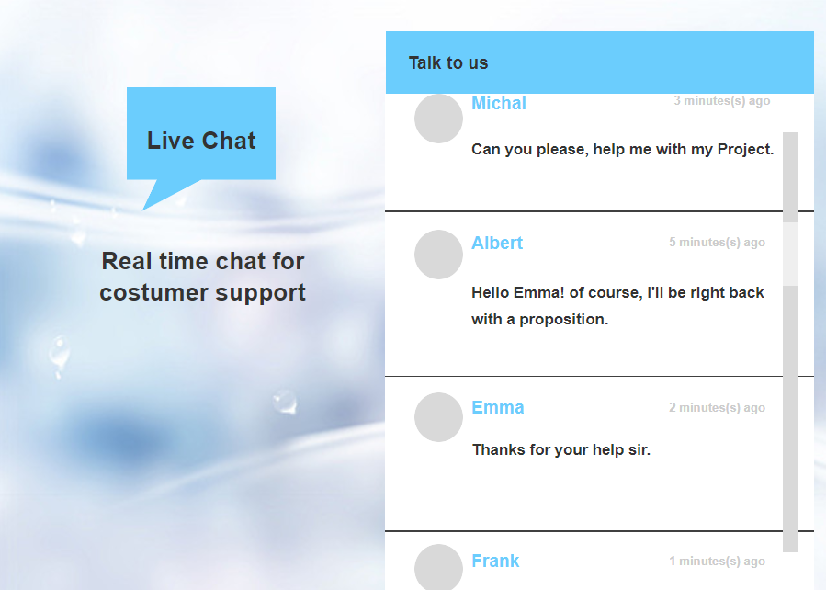

1. ***Support Live Chat*** – Here user can interact with developer in real time.
   * Things included in Support Live Chat are: –

* Live developer – User can chat with them here.
* Live users – Developer can get the issues from the users.

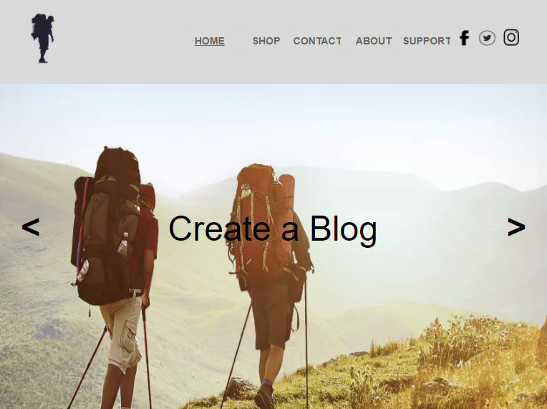

1. ***Host blog*** – A blog is the organization that gives the space on its servers and gear to store your blog. Thusly, the blog can be come to by anybody online over the web. Commonly, a blog has supplier charges a little expense to store your blog on its server. In spite of the fact that there are some free blog facilitating organizations, their administrations are regularly constrained. Built up blogging has given an assortment of subordinate administrations, and some blog has given blogging programming also.

* Things included in Host blogare: –
* Home – By clicking this button you will navigate to the main page wherever you are on in the website.
* Shop – In this you can buy paid domains and free domains.
* Contact – Here user will get our social media links and contact number.
* About – This will contain all the information of our blogger website and also the description of our website.
* Support – Here user will get Support Form, Support Live Chat, Webinars etc.

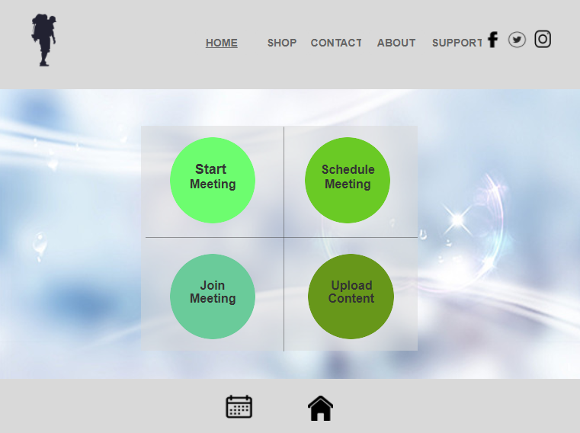

1. ***Schedule live talks, mixers, and other events*** – In this section user can do Schedule meetings, start meeting, join any meeting, and upload content there. Calendar is also provided there to mark date and monthly schedules there.

* Things included in Schedule live talks, mixers, and other events are: -
* Start meeting- In this section user can start a meeting and invite others, those interested to join the meeting.
* Schedule meeting- In this section user can schedule a meeting before the time. It is basically a notice for upcoming meeting.
* Join meeting- It is for those how want to join already happing meeting.
* Upload content- In this section user can upload their files, documents, etc. related to meetings.

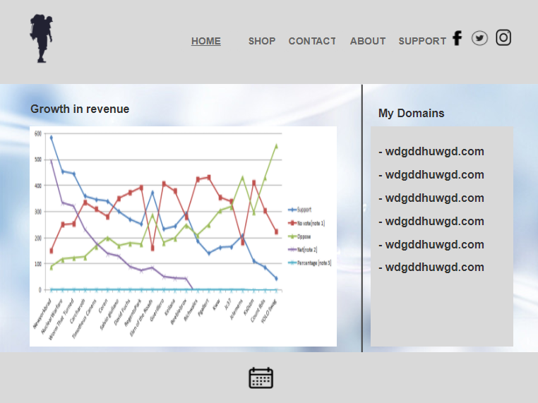

1. ***Network of clients, interested professionals and students:*** - This section is made for users to analysis their stuff, check their grow online, list all there paid or free domains. There is a proper graph like bar, line graphs to check their progress.

* Things included in Network of clients, interested professionals and students are: -
* Graphs- These graphs help user to saw there progress online. All their down falls, and ups are alimented there.
* My Domains- In this section user can see there paid or free domains. All are list by date and time. And tell whether domain working or not.
* Calendar- It help user to set date and day for meetings, all things get scheduled nicely there.

**RESEARCH**

For business purposes I went to SurveyMonkey.com and did a survey and want tot share that survey and information with my clients. Further, I will post the screenshots of the survey to you all from my g-mail account [**Weblog@gmail.com**](mailto:Weblog@gmail.com)**.**

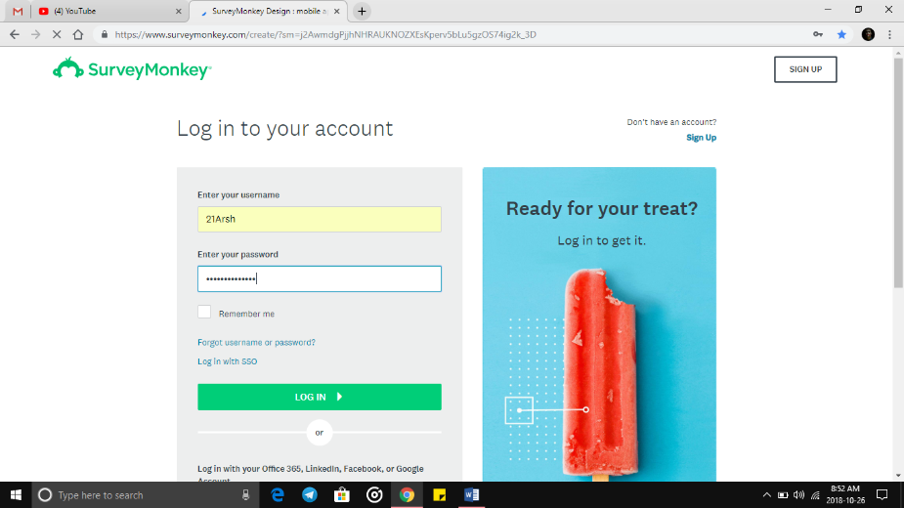

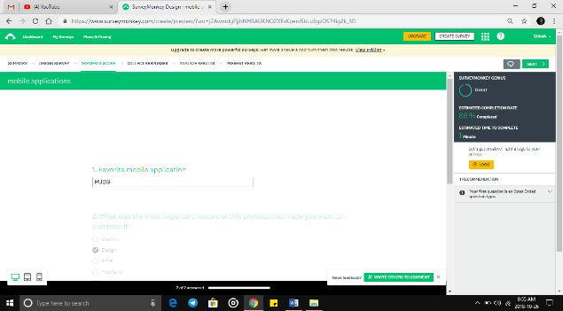

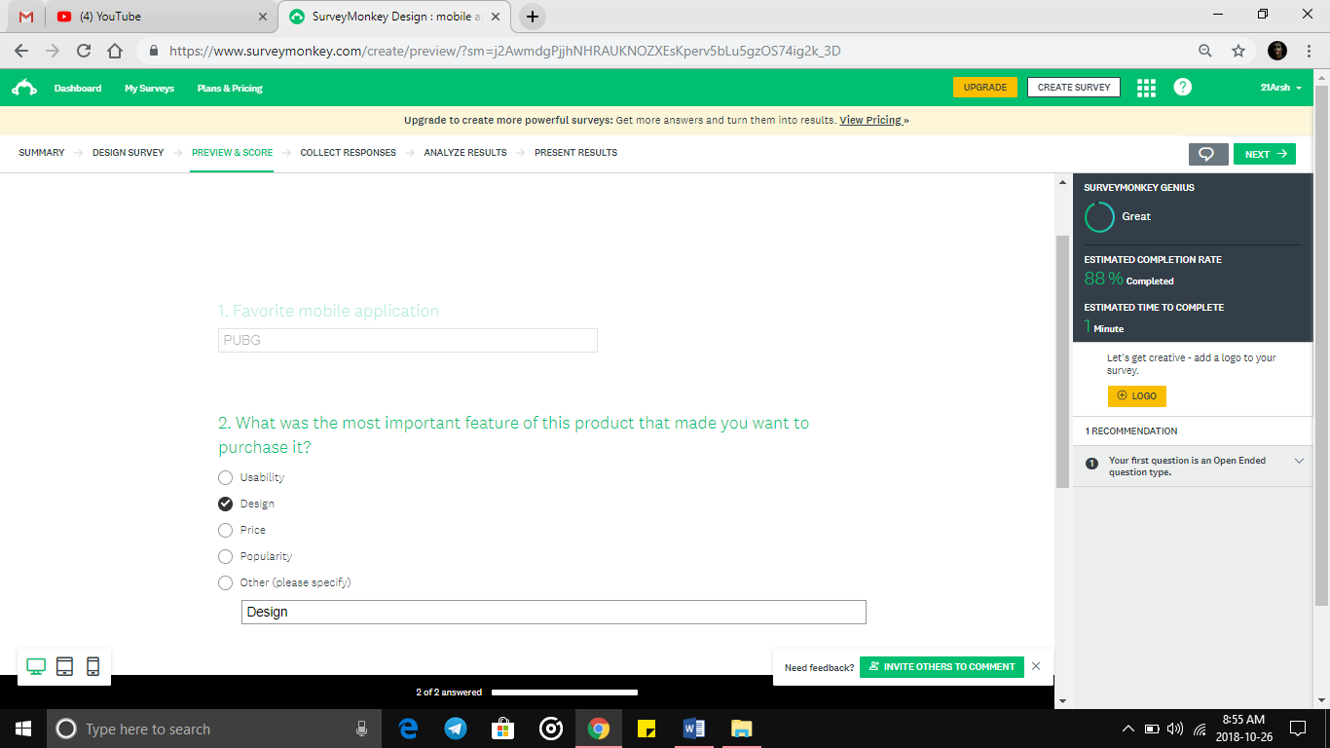

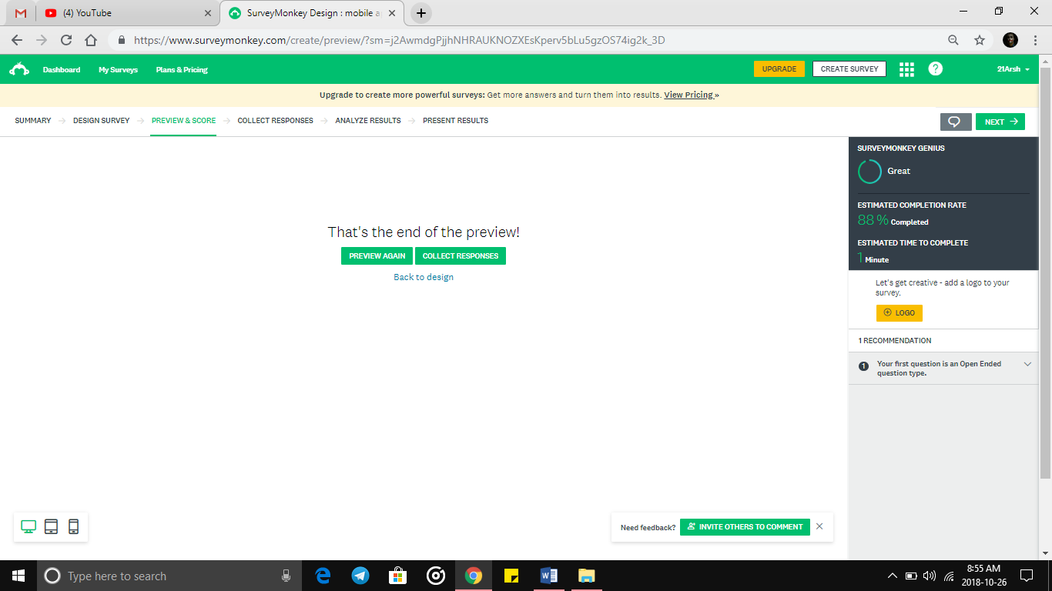

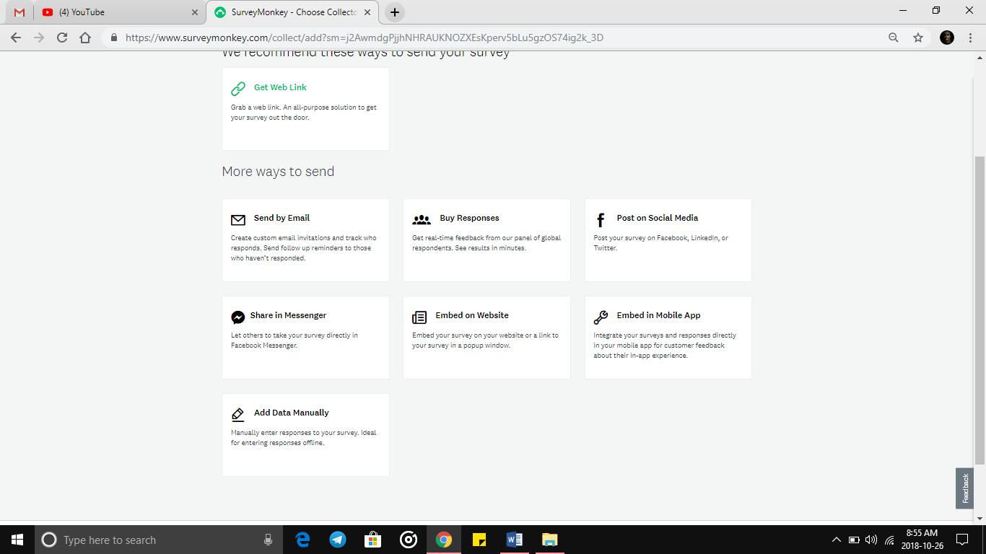

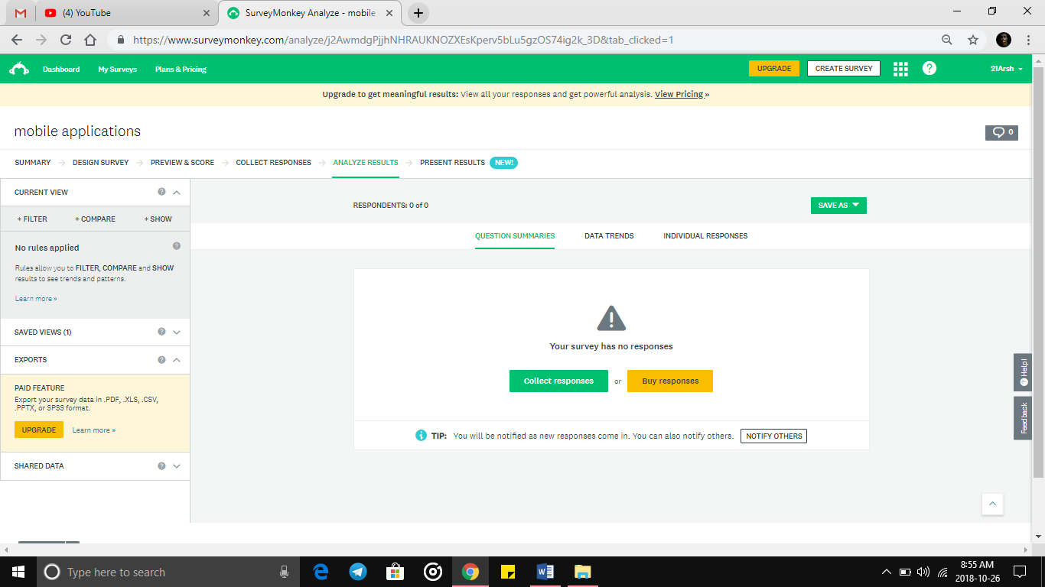

**Technical issue**

Special Services, Hardware and Features that our website required are: -

* Internet – Our first need is internet to open our website.
* *Browser* – We need browser to visit our website. For-e.g.: - Chrome, Firefox and etc.
* *Computer* – We also need computer to open our website.
* *Android operating system* – Our website can also work in android phones.
* *IOS operating system* – Our website can also work in IOS system.
* *Location* – Users have to turn on their location before they visit our website.
* *GPS* –While turning on the location the GPS will help us to find from where are user is operating our website

Special Input Controls that our website need: -

* Keyboard
* Language and dock
* Accessibility
* Display
* 4k Display for good graphics
* Amoled Screen for better visibility
* Advantages
* Cheap
* Easy to use
* User friendly
* Can work on low internet connection
* No advertisement
* No popups

**PERSONAS**

**1.Anirudh**

* He is an adult 20 years old.
* College Student.
* Lives in Chandigarh.
* He is Single.
* Hobbies – Football, Music, Travelling.
* Computer Skills- Expert (Website maker, Gamer, online shopping, sending E-mail)
* Website relative to blogs that he visits are- blogger.com, mybloges.com
* Goals for website- Fully optioned interface, user friendly, Category list, cheap domains, no advertisements.

**2. Aditya**

* He is an adult 19 years old.
* College student.
* Lives in Mohali.
* He is a committed.
* Hobbies- Composing music, Writing lyrics.
* Computer skills- Expert (Website maker, Gamer, applications maker, online shopping)
* Websites relative to blogs that he visits are-goblogs.in, moblogs.com, openbloges.com.
* Goals for website- Cheap rates on domains, templates for getting ideas for website, no advertisements or popups.

**3.Inderpreet Singh**

* He is an adult 20 years old.
* College student.
* Lives in Ludhiana.
* He is a committed.
* Hobbies- online gaming, music listener.
* Computer skills- Learner (Gamer, online shopping, charting, E-mails, watching movies)
* Website relative to blogs that he visits are- moblogs.com, dimonblogs.in.
* Goals for website- Cheap rate on domains, Simpler interface, less options, ad free, templates to get things started.